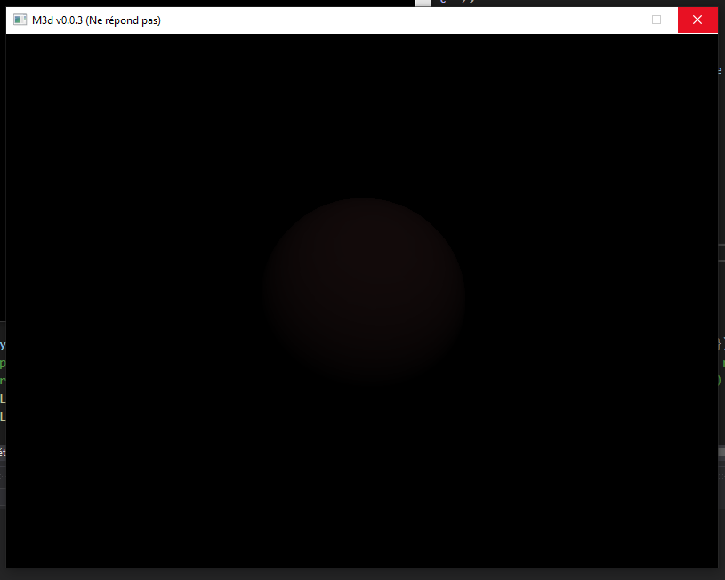

First result as phong implémentation on a sphere

I don’t know how to increase the lightningof the scene… Trouvé :

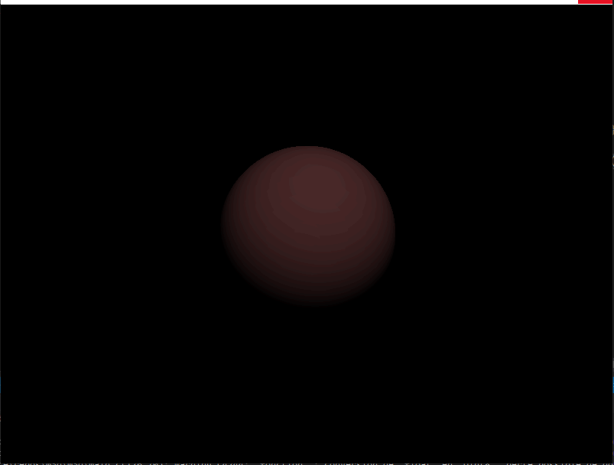

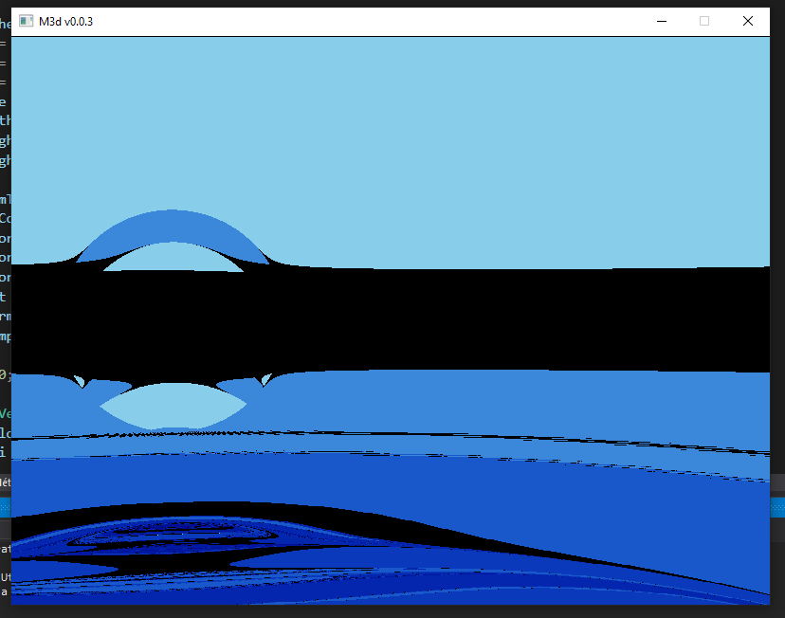

First attempt at reflexion model